summary

|  |  |
| --- | --- |
| Count of  Transformed_  Housing_Data | **21,609** |
| Average Sales Prices | **511,619** |
| Area Of The House  From Basement(in  sqft) | **38,643,798** |

|  |  |
| --- | --- |
| Total Sales By Years Since Renovation | Years Since Renovation  0 413 |
| Sale_Price (bin) |

# Distribution Of Houses By Renovation Status

118

96

94

88

76

75

71

68

63

50

Age of House (in Years)

50

63

68

71

75

76

88

94

96

118

Ever Renovated Yes

204

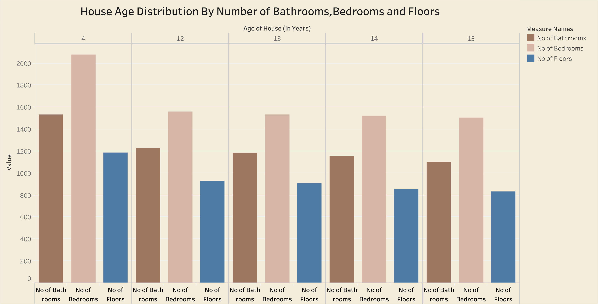

**Comprehensive House Price Analysis**

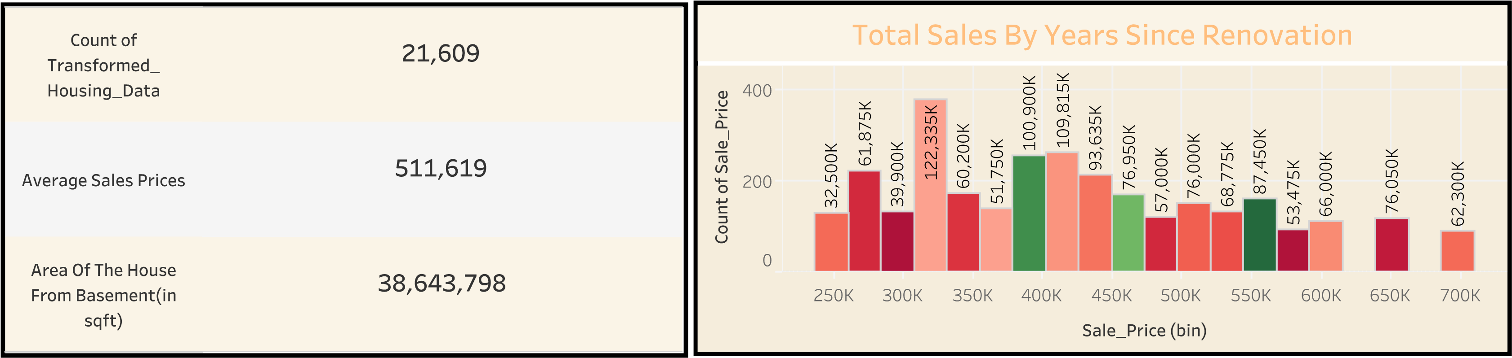

|  |  |  |  |  |  |  |  |  |
| --- | --- | --- | --- | --- | --- | --- | --- | --- |
| **Distribution Of Houses By Renovation**  **Status** | **House Age Distribution By Number of**  **Bathrooms,Bedrooms and Floors** | | | | | | | |
|  | V  a  l  u  e | 2K  1K  0K | 4 | 12 | Age of House (in Years)  13 | 14 | 15 |
| 118  96  94  88  76  75  71  68  63  50 |
|  |  |  |  |  |
|  |  |  |  |  |
|  |  |  |  |  |
| **N**  **o**    **o**  **f**    **B**  **.**  **.**  **N**  **o**    **o**  **f**    **B**  **.**  **.**  **N**  **o**    **o**  **f**    **F**  **.**  **.** | **N**  **o**    **o**  **f**    **B**  **.**  **.**  **N**  **o**    **o**  **f**    **B**  **.**  **.**  **N**  **o**    **o**  **f**    **F**  **.**  **.** | **N**  **o**    **o**  **f**    **B**  **.**  **.**  **N**  **o**    **o**  **f**    **B**  **.**  **.**  **N**  **o**    **o**  **f**    **F**  **.**  **.** | **N**  **o**    **o**  **f**    **B**  **.**  **.**  **N**  **o**    **o**  **f**    **B**  **.**  **.**  **N**  **o**    **o**  **f**    **F**  **.**  **.** | **N**  **o**    **o**  **f**    **B**  **.**  **.**  **N**  **o**    **o**  **f**    **B**  **.**  **.**  **N**  **o**    **o**  **f**    **F**  **.**  **.** |

|  |  |  |  |  |  |  |  |  |  |
| --- | --- | --- | --- | --- | --- | --- | --- | --- | --- |
|  | | House Age Distribution is more influenced by the number of bedrooms compared to bath.. | | The Age of Houses varies based on their renovation status ,providing a comprehensi.. | | The importance of Recent Renovations in boosting property sales. | | |  |
| **House Age Distribution By No Of Bathrooms, Bedrooms and Floors** | | | | |  | |
| 0  500  1000  1500  2000  V  a  l  u  e | |  | | | | | Measure Names  No of Bathrooms  No of Bedrooms  No of Floors | | |
|  | | | | |
| House Age Distribution is more influenced by the number of bedrooms compared to bath.. | | The Age of Houses varies based on their renovation status ,providing a comprehensi.. | | The importance of Recent Renovations in boosting property sales. | | |

204

118

96

94

88

76

75

71

68

63

50

Age of House (in Years)

50

63

68

71

75

76

88

94

96

118

Ever Renovated Yes

**Distribution of House age by Renovation status**

|  |  |  |
| --- | --- | --- |
| House Age Distribution is more influenced by the number of bedrooms compared to bath.. | The Age of Houses varies based on their renovation status ,providing a comprehensi.. | The importance of Recent Renovations in boosting property sales. |

